You will keep record of all of the experiments, activities, and demonstrations in a lab notebook. This notebook will be used as a reference for completing submitted work. It may be collected to support your assignments as evidence. You will get a quarterly grade for keeping your lab notebook up to date and complete. You may photograph and store a copy of your lab notebook online if you prefer in a portfolio but still need to keep this written record.

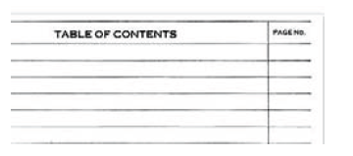 | Leave several pages blank at the beginning of the notebook for a Table of Contents and update it when you start each new experiment or topic.
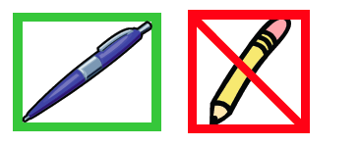 | Always use pen and write neatly and clearly.
 | Date and number every page on the top outside corner.
 | Start each new topic on a right side page. (experiment, notes, calculations, etc. begin on odd numbered page) Skip pages if necessary to keep topics together. Restart topics and note the earlier work they continue in the table of contents if necessary.
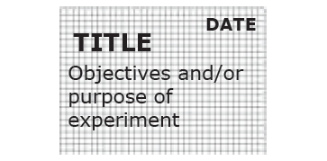 | Record the Title and Objectives of each experiment at the top of the first page of the notebook dedicated to this topic.
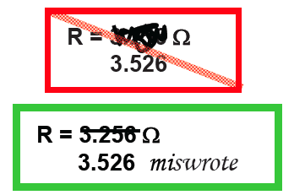 | If you make a mistake, don’t black it out! Use a single cross out and EXPLAIN why it was and error. You may need to read or refer to your mistake later. This way, you can follow your steps and prove what you did.
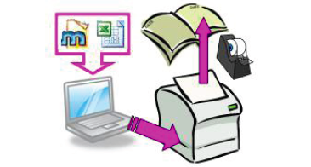 | Data typed into a computer must be copied into the notebook or printed out and taped into the notebook. You may also tape in drawings or graphs.
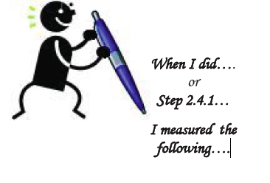 | When you record an observation in your notebook, include an explanation of what you were doing at the time and why it is important. If appropriate, you may record the step number from the lab instructions.

Lab Notebook Rubric

Criterion | Requirements | Value (pts)
Pen | Write in pen, not pencil | 2
Date | Date and page number on every page at the top | 2
Right Side | Begin each experiment on an odd page | 2
Printouts | Attach printouts, diagrams, and plots of data as needed | 2
Legible | Obvious care taken to make it readable, even if you have bad handwriting (use rulers) | 2
Mistakes | Mistakes crossed out with one line and explained | 2
Organized | - Table of contents  - Title of experiment on 1st page  - Objectives of experiment  - Clear explanation of what you were doing. Use description of steps performed and pictures. | 4
Informative | - All required data and information  - Descriptive comments of your observations | 4

